Architecture Document

- Application: The Automated AI Legal Rights Evaluation System will be implemented as a cloud-native, scalable application designed for reliability, security, and maintainability. The architecture emphasizes modularity to accommodate evolving legal frameworks across jurisdictions and rapid incorporation of new AI assessment methodologies.

  - Microservices: The application will be decomposed into a set of loosely coupled, independently deployable microservices, each owning a specific domain of the business logic. This modularity allows teams to develop, scale, and update components like the classification engine or a specific jurisdiction's rule set without impacting the entire system. For example, a Document Ingestion Service will handle parsing various file formats, a Classification Service will run the zero-shot ML models to identify legal attributes, and a dedicated Rules Engine Service will apply the formal logic of different legal frameworks. These services will communicate through well-defined APIs (using REST for external calls and gRPC for internal performance-critical communication), managed by an API Gateway that handles routing, security, and rate limiting.

  - Event-Driven: To ensure responsiveness and resilience, the system will employ an event-driven architecture centered on a robust event bus like Apache Kafka. This approach decouples services, allowing them to react asynchronously to state changes. Key events such as DocumentProcessed, ClassificationComplete, and EvaluationComplete will be published to the bus. This means the Reporting Service doesn't need to poll the Rules Engine; it simply listens for the EvaluationComplete event to trigger report generation. This model provides a complete, replayable audit trail of every evaluation, supports real-time updates (e.g., instantly pushing a new legal framework version to all running evaluations), and enables independent scaling of event consumers based on load.
  - Serverless: The final architecture will be a hybrid, combining long-running containerized microservices for core stateful components with serverless functions for event processing, creating a balance of control and agility.
- Database
  - Sequence Diagram

  - Schema Design
- Data Exchange Contract
  - Frequency of data exchanges
  - Data Sets
  - Mode of Exchanges (API, File, Queue etc.,)
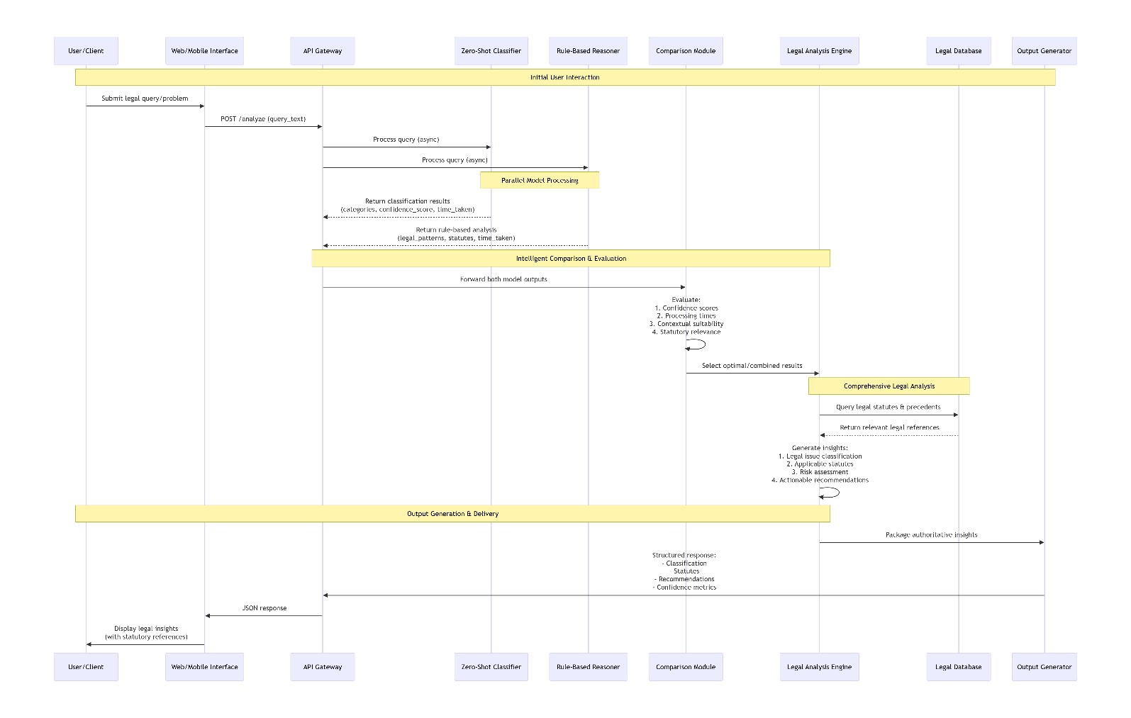

2. Class Diagram
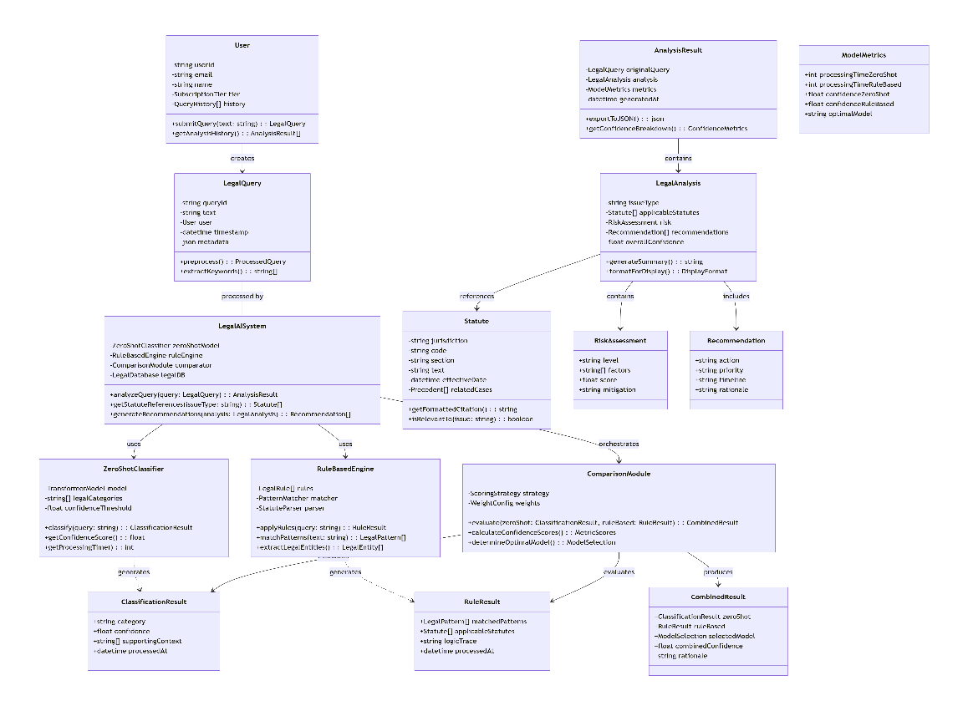

3. Schema Design

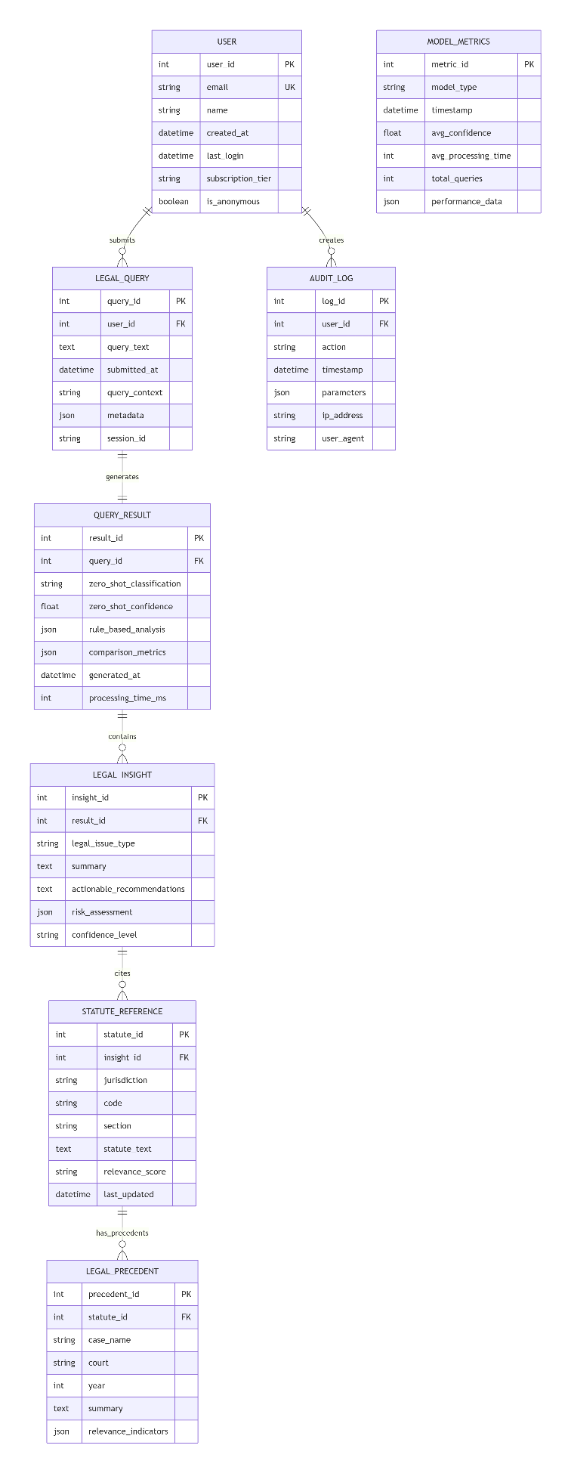
- Data Exchange Contract
  - Frequency of data exchanges
The proposed legal AI system operates on a multi-tiered temporal architecture with distinct exchange frequencies optimized for different system components. At the real-time interaction layer, data exchanges occur in milliseconds to seconds as users submit legal queries through web or mobile interfaces. The dual-model architecture necessitates parallel processing pathways where the zero-shot classifier and rule-based engine simultaneously process inputs, requiring synchronous data exchanges within 50-500ms windows to maintain responsive user experiences. These high-frequency exchanges are characterized by low-latency requirements and involve lightweight payloads primarily consisting of query text and metadata.

Moving to the operational intelligence layer, data exchanges shift to seconds to minutes intervals. User session management maintains stateful connections with 1-5 second update cycles, while model performance metrics aggregate every 5-30 seconds to monitor system health and accuracy.

  - Data Sets
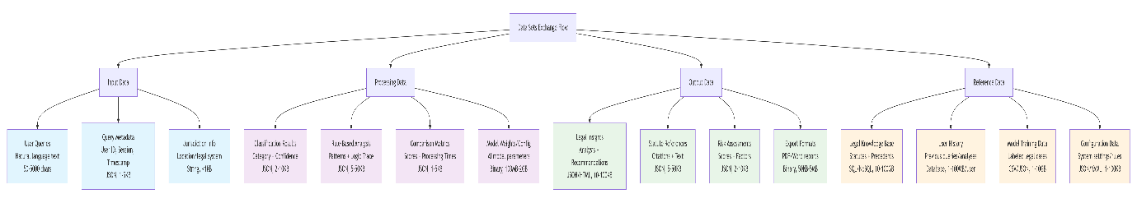
The system manages four primary data set categories with distinct characteristics and exchange patterns. Input data sets originate from user interactions and include natural language legal queries (50-5000 characters), query metadata (JSON formatted, 1-5KB containing user ID, session tokens, and timestamps), and jurisdiction information specifying the relevant legal system or geographical location (typically under 1KB). These data sets follow a lightweight, text-centric design optimized for rapid transmission and preprocessing, with metadata structured to support both analytical tracking and personalization.
Processing data sets represent the intermediate artifacts generated during legal analysis. Classification results from the zero-shot model include identified legal categories, confidence scores, and supporting context (JSON, 2-10KB). Rule-based analysis outputs contain matched legal patterns, logic traces, and applicable statute references (JSON, 5-50KB). Comparison metrics capture the intelligent evaluation between models including confidence scores, processing times, and contextual suitability assessments (JSON, 1-5KB). Model weights and configurations represent the largest processing data sets (100MB-2GB), exchanged during training and deployment cycles rather than real-time operations.

  - Mode of Exchanges (API, File, Queue etc.,)
The system implements a heterogeneous exchange architecture selecting optimal modes for different data flow requirements. Client-layer exchanges primarily utilize HTTP/HTTPS REST APIs for web browser interactions, providing stateless, cacheable communication with JSON payloads. Mobile applications employ gRPC and WebSocket connections for improved performance and real-time updates. Third-party integrations use OAuth 2.0 authenticated REST APIs with rate limiting and structured error handling. These exchanges prioritize security, reliability, and developer accessibility.
API-layer exchanges implement service-oriented communication with HTTP/REST for internal service calls and message queuing (RabbitMQ/Kafka) for asynchronous processing. The load balancer distributes requests across analysis service instances, while message queues decouple the API gateway from model processors, enabling scalability and fault tolerance. This layer manages request/response cycles, authentication propagation, and transaction correlation across distributed components.
Processing-layer exchanges employ direct method calls and RPC/gRPC for high-performance internal communications. The zero-shot service communicates with transformer models via optimized RPC protocols, while the rule engine directly accesses rule databases.
